Crypto Definitions

- Key clustering: different encryption keys generate the same ciphertext from the same plaintext message
- Synchronous: encryption or decryption request is performed immediately
- Asynchronous: Encrypt/Decrypt requests are processed in queues
- Hash function: a one-way mathematical operation that reduces a message or data file into a smaller fixed length output, or hash value
  - Variable data input (of any size) + hashing algorithm = fixed bit stream output (hash value)
    - MD5 = 128 bits
    - SHA1 = 160 bits
- Digital signatures: provide authentication of a sender and integrity of a sender’s message. A message is input into a hash function. Then the hash value is encrypted using the private key of the sender. The result of these two steps yields a digital signature
- Symmetric: A single key used to encrypt and to decrypt
- Asymmetric: two different but mathematically related keys are used where one key is used to encrypt and another is used to decrypt
- Digital certificate: used to identify the certificate holder when conducting electronic transactions – Type of certificates currently used = X.509 v3
- Certificate authority (CA): an entity trusted by one or more users as an authority in a network that issues, revokes, and manages digital certificates
  - Root CA – only issues certificates to Subordinate CA’s
  - Subordinate CA – issues certificates to users + computers on behalf of the Root CA
- Registration authority (RA): responsible for the accuracy of the information contained in a certificate request. The RA is also expected to perform user validation before issuing a certificate request
- Plaintext or cleartext
- Ciphertext or cryptogram
- Cryptosystem: This represents the entire cryptographic operation. This includes the algorithm, key, and key management functions
- Encryption
- Decryption
- Key or Cryptovariable: The input that controls the operation of the cryptographic algorithm
- Non-repudiation
- Algorithm
- Cryptanalysis: study of techniques for attempting to defeat cryptographic techniques and information security services
- Cryptology: the science that deals with hidden, disguised, or encrypted communications
- Collision: occurs when a hash function generates the same output for different inputs
- Key space: represents the total number of possible values of keys in a cryptographic algorithm or other security measure, such as a password
- Work factor: the time and effort required to break a protective measure
- Initialization vector (IV): A non-secret binary vector used as the initializing input algorithm for the encryption of a plaintext block sequence to increase security by introducing additional cryptographic variance
- Encoding: The action of changing a message into another format through the use of a code
- Decoding: The reverse process from encoding – converting the encoded message back into its plaintext format
- Transposition or permutation – Swapping/Shifting of blocks of text
- Substitution – Changing some part of the plaintext for a different value
- SP-network: substitution and permutation (transposition), most block ciphers do a series of repeated substitutions and permutations to add confusion and diffusion to the encryption process
- Confusion: provided by mixing (changing) the key values used during the repeated rounds of encryption
- Diffusion: provided by mixing up the location of the plaintext throughout the ciphertext
- Avalanche effect: where a minor change in either the key or the plaintext will have a significant change in the resulting ciphertext
- Stream Cipher: cryptosystem performs its encryption on a bit-by-bit basis
- Block Cipher: operates on blocks or chunks of text
  - Electronic Code Book (ECB) – Each block is encrypted independently, BUT identical plaintext blocks are encrypted into identical ciphertext blocks

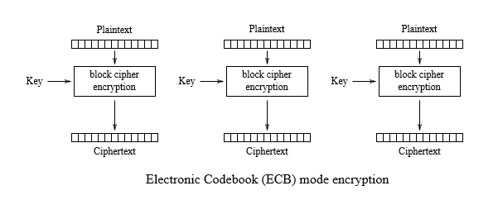

- Cipher Block Chaining (CBC) – Each block of plaintext is XORed with the previous ciphertext block before being encrypted. This way, each ciphertext block depends on all plaintext blocks processed up to that point. To make each message unique, an initialization vector must be used in the first block.

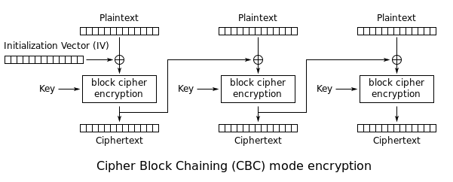

- Propagating Cipher Block Chaining (PCBC) – Each block of plaintext is XORed with the XOR of the previous plaintext block and the previous ciphertext block before being encrypted. As with CBC mode, an initialization vector is used in the first block.

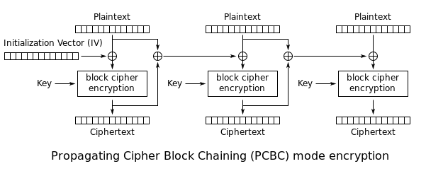

- Cipher Feedback (CFB): Allows encryption of partial blocks rather than requiring full blocks for encryption. This eliminates the need to pad a block like in CBC.

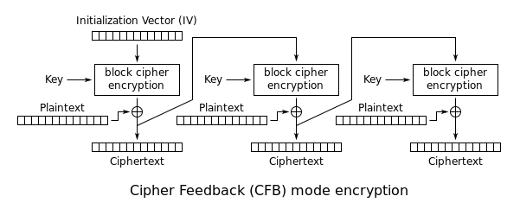

- The Output Feedback (OFB) mode makes a block cipher into a synchronous stream cipher. It generates keystream blocks, which are then XORed with the plaintext blocks to get the ciphertext.

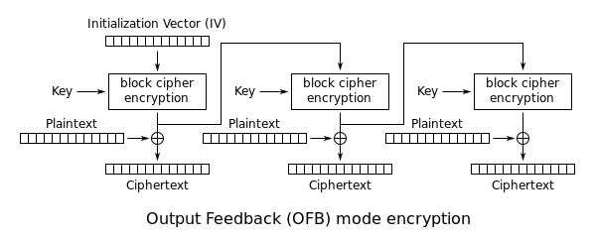

- Like OFB, Counter mode turns a block cipher into a stream cipher. It generates the next keystream block by encrypting successive values of a "counter".

